- In your application, select File and Print, then click on the preferences button.
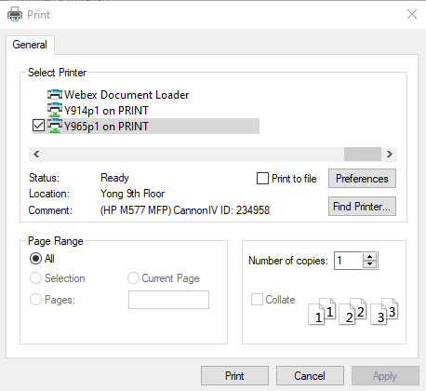
- Go to the Job Storage tab and click on Personal Job and then click on the OK button.
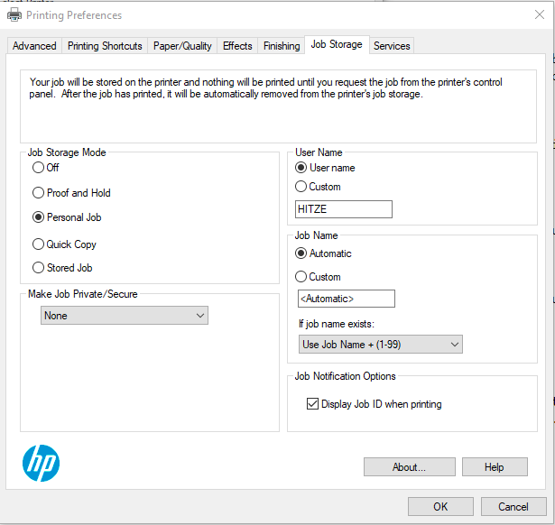
- Click on the Print button to send the job to the printer.
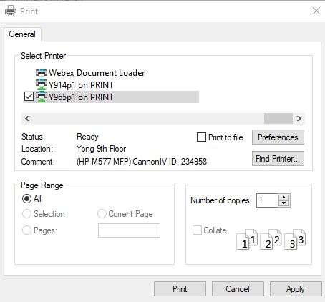
- Click on the OK button at the Job Storage Identification message box.
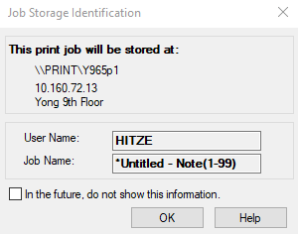
- Go to the printer and click on ‘Print from Job Storage’.
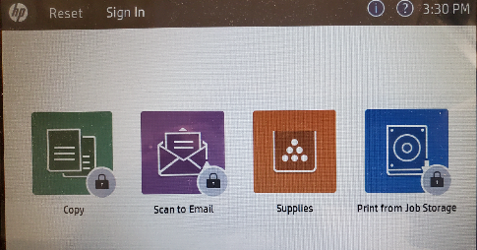
- Sign in to the printer using your Copy PIN code.
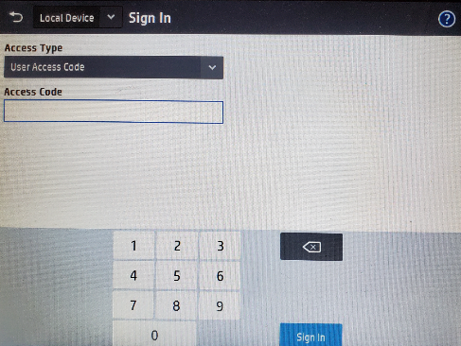
- Click on the folder with your user name.
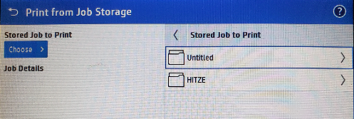
- Select the print jobs that you want to release.
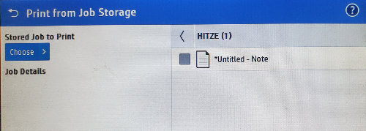
- Click on the Print button.
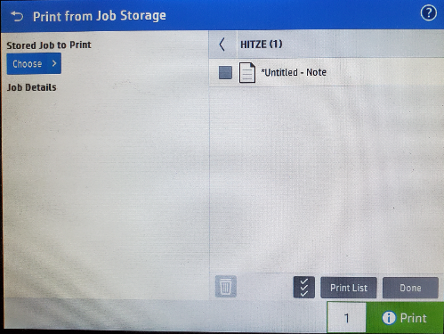
- This is a print verification page. It is misleading, don’t’ click on print again.
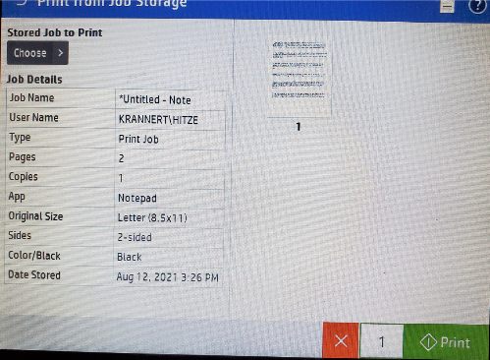
- After the jobs print, don’t forget to logout.

Additional Options:
By default, the option in ‘Make Job Private/secure seen in step 2 above is set to None.
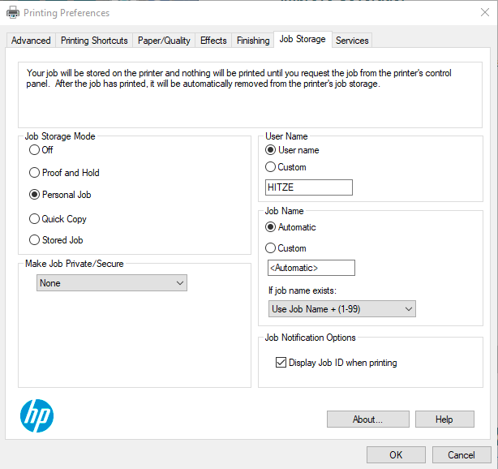
You have 2 other options, ‘Print to PIN’ or ‘Encrypt Job (with password)’. Be careful here, there is no recovery if you forget the PIN or password entered. You would just have to print again.
If you select ‘Print to PIN’, it will give you another space to enter a PIN. This is not you Copy Code PIN, it is just something that you associated with this print job. It also can be set differently each print job.
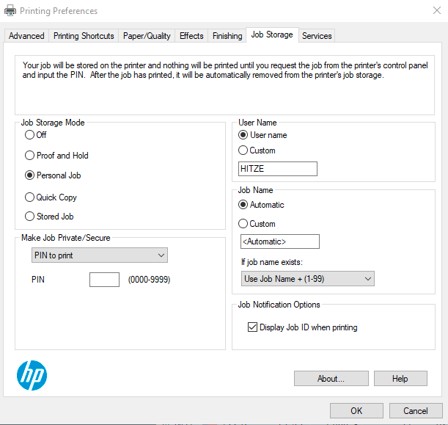

If you select ‘Encrypt Job (with password)’, it will prompt you for a password after you click on the OK, then Print buttons.
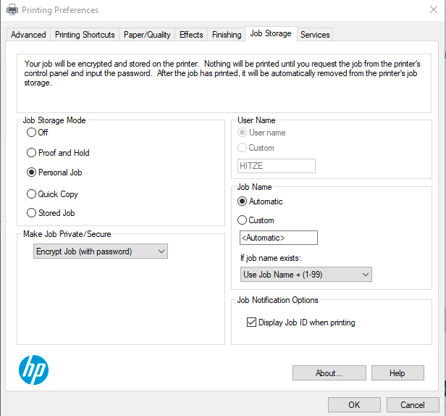
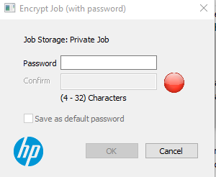
This is not your logon password, just something that you choose to associate with this print job.

